

**Class:**

ECE 304

Section A

Final Project Report

Motion Detector

**Submitted to:**

Dr. Scott

Electronics

**Submitted by:**

Marguerite Smith

Alecea Grosjean

Shaun Valentine

**Date:**

December 2, 2022

### Table of Contents

[Introduction](https://docs.google.com/document/d/1zcCUjD6gssCBgVj-G4MCUh__qqsFAtOJF3jyPUsF6nI/edit#heading=h.6hzv6snb70y) 3

Circuit Theory [3](https://docs.google.com/document/d/1zcCUjD6gssCBgVj-G4MCUh__qqsFAtOJF3jyPUsF6nI/edit#heading=h.97q7h8z7v8ph)

Simulation Model and Results 10

Experimental Results 1[4](https://docs.google.com/document/d/1zcCUjD6gssCBgVj-G4MCUh__qqsFAtOJF3jyPUsF6nI/edit#heading=h.51hu4hf1a143)

Analysis of the Results 16

Conclusion 17

Appendix 19

### Introduction

The circuit discussed in this report is an infrared motion detector using an NE555 timer IC for AC load control and an IR sensor module for sensing motion. Some key components of the circuit are a BC547 NPN Transistor which functions as a switch, an op amp for voltage gain, a single pole double throw relay, as well as the NE555 integrated circuit and IR sensor module discussed earlier. Additionally, LEDs, resistors, wires and capacitors were used. Refer to the bill of materials in the appendix for a full list of part numbers and quantities used in the circuit.

Motion detectors are commonly used around campus, from lights coming on as one walks into a room to temperatures adjusting based on occupancy. This circuit targets high school and freshmen college students’ interests and engagement, for learning the functionality of something that one comes into contact with every day. The applicability of motion detectors should not decrease in the foreseeable future, so incoming students will find an understanding of their operations interesting and useful.

Our report dissects the circuit building process beginning with the theory behind our circuits functionality, followed by an explanation of the simulated representation of the circuit using LTSpice, and the experimental results of the physically constructed circuit. The report concludes with an analysis of the similarities and differences between the stages of circuit construction and an overview of the steps taken during the project resulting in a comprehensive report about our IR sensor circuit and its functionality.

### Circuit Theory

Materials

IR Sensor Module

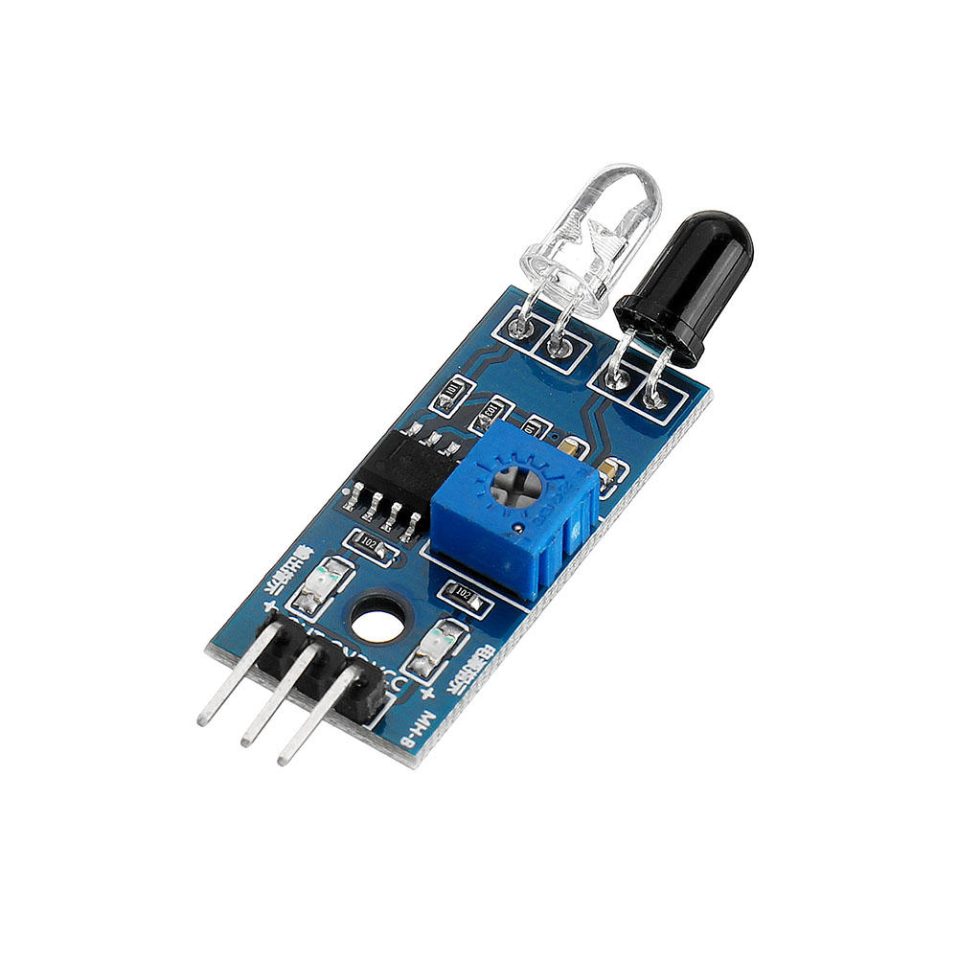

Figure 1: IR Sensor Module (BOM Item #2)

One component of an infrared motion detector circuit is an infrared sensor module. We selected a Gikfun obstacle avoidance Infrared Sensor Module which has two input pins Vcc and GND and an output pin that outputs a low or high voltage depending on the presence of motion. These modules are able to detect motion due to their two sensors, one being an IR LED emitter and an IR Photodiode receiver. The IR LED emits IR radiation while the IR Photodiode detects IR radiation. When used together the radiation from the IR LED bounces off objects and reflects back to the IR Photodiode. Depending on the intensity of the response the sensor can output different amounts of voltage. The module has a constant high voltage of 5 V when no motion is detected and is switched to ground (0V) when motion is detected.

NE555 Timer

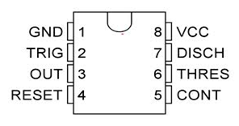

Figure 2: NE555 Pin Out

The NE555 timer (BOM Item #1) has 8 pins, 6 of which are utilized in this circuit. This integrated circuit has a voltage-controlled output over time which allows us to control the output voltage to our LED to indicate motion based on the voltage output by the IR sensor module. This process also allows for the reset of the IC when motion is no longer detected.

Pin 1 and 8 are input pins for the values of ground and Vcc respectively. Pin 3 is an output pin, which is controlled by the values of the input pins 2, 5, and 6. Since pin 5 has no input for this circuit the control voltages for the IC are $\frac{1}{3}⋅Vcc$ for the trigger (pin 2) and $\frac{2}{3}⋅Vcc$ for the threshold (pin 6).

The output of pin 3 will be “low” or approximately 0V until the input to pin 2, the trigger, falls below ⅓ the value of Vcc and the internal flip flop of the IC is set. After this, the value of pin 3 is “high” or approximately Vcc until the flip-flop is reset. Pin 4, the reset pin, is an input that can be triggered for a “low” signal. Pin 4 is connected to Vcc in this circuit so that the flip flop is only reset due to the input of the IR module. The only way that the output of pin 3 can be reset is when the trigger (pin 2) is above $\frac{1}{3}⋅Vcc$ and the threshold value (pin 6) is above $\frac{2}{3}⋅Vcc$. This causes the flip flop to reset and the output value of pin 3 to be “low”.

BC547 NPN Transistor

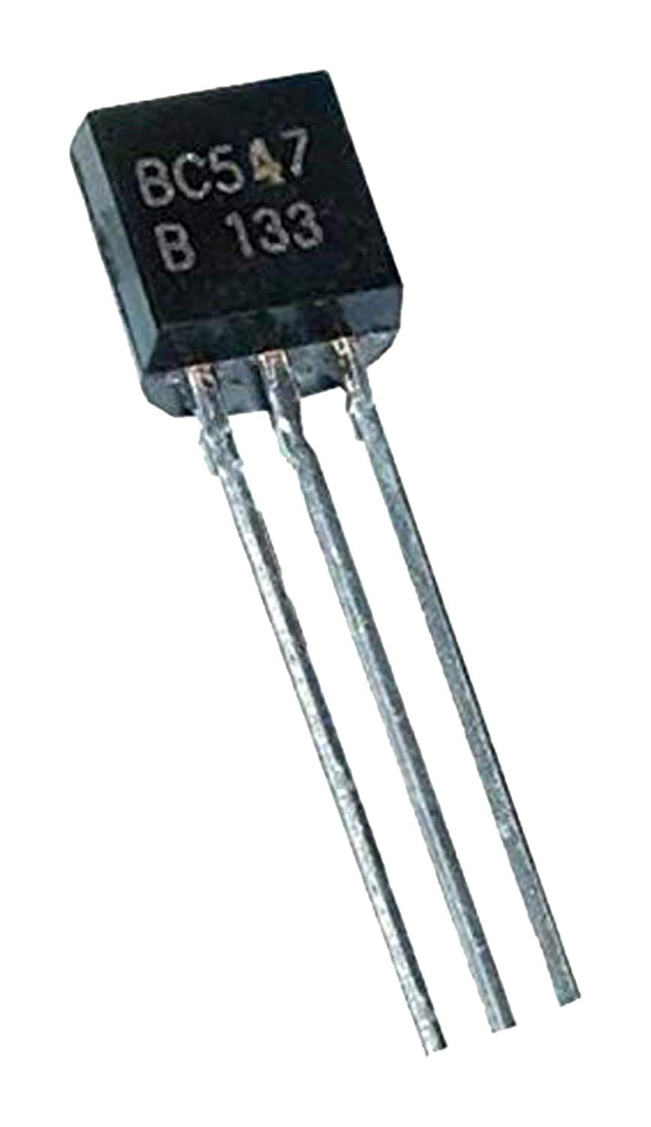

Figure 3: BC547 (BOM Item #12)

Bipolar Junction Transistors like the BC547 NPN transistor used in this circuit operate in 3 different modes known as cut-off mode, saturation mode, and active mode. The transistor is in cut-off mode when the voltage across the base and emitter is less than 0.7V. In this mode, the transistor acts as an open circuit and no current is flowing. The transistor is in saturation mode when the voltage across the base and emitter is greater than or equal to 0.7V and the voltage across the collector and emitter is equal to 0.2V. In this mode, the transistor acts as a closed circuit and current flows through the transistor. The transistor is in saturation mode when the voltage across the base and emitter is greater than or equal to 0.7V and the voltage across the collector and emitter is greater than 0.2V. In this mode, the transistor acts as a current amplifier.

We will use the transistor in this circuit as a switch using the cut-off and saturation modes.

Explanation of Schematic

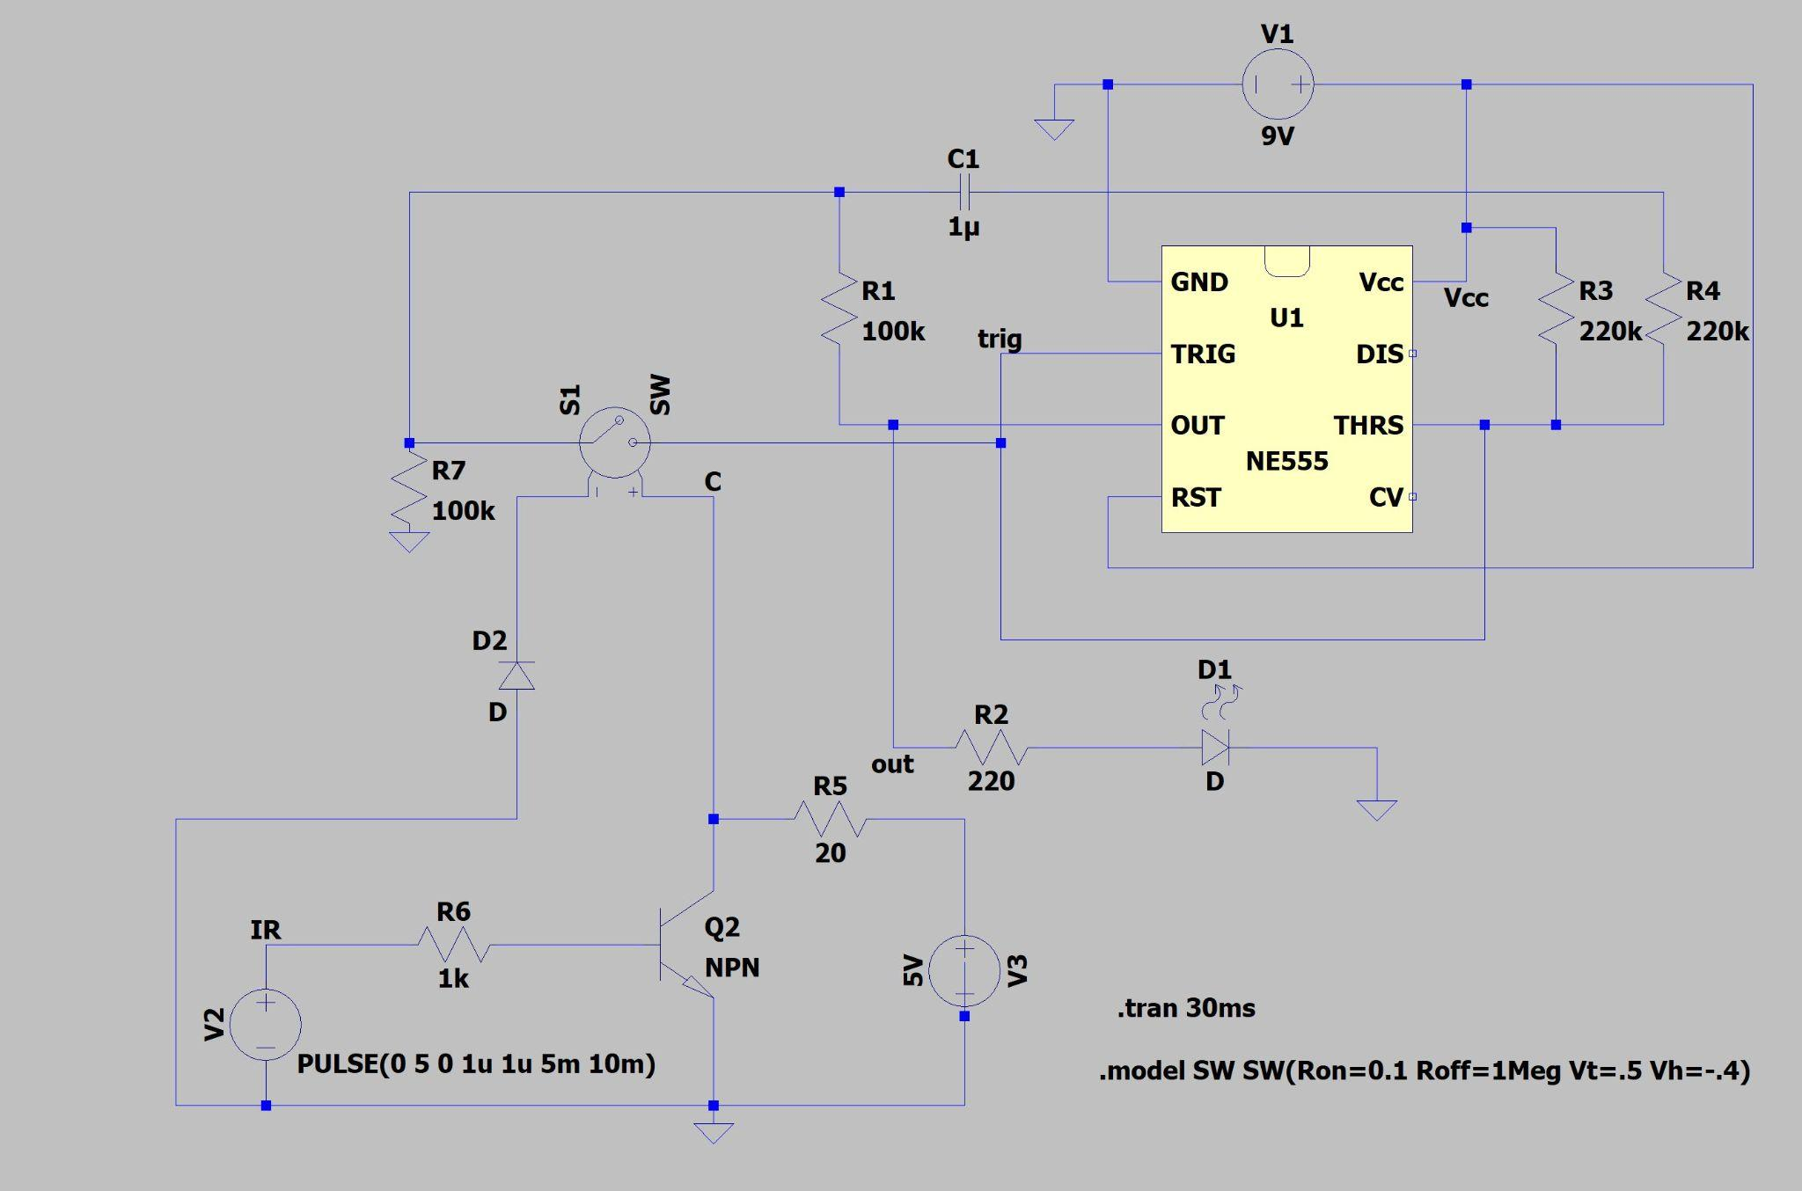

Figure 4: IR Motion Detector Schematic

Analysis of the behavior of the circuit using circuit theory will be completed for a series of three time events:

1. Before motion is detected by the sensor.
2. After motion is detected by the sensor.
3. When no motion is detected again after event 2.

Before Motion is Detected

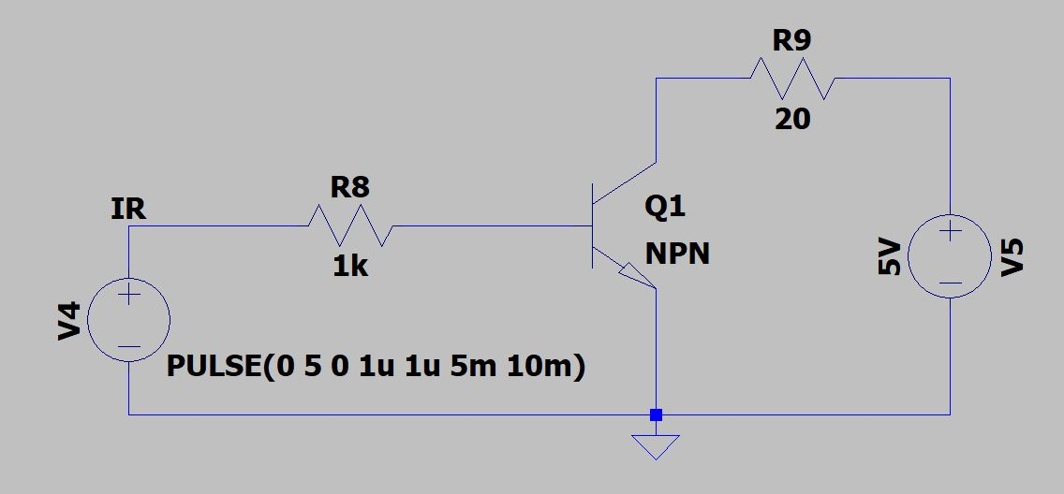

Figure 5: NPN Transistor Circuit

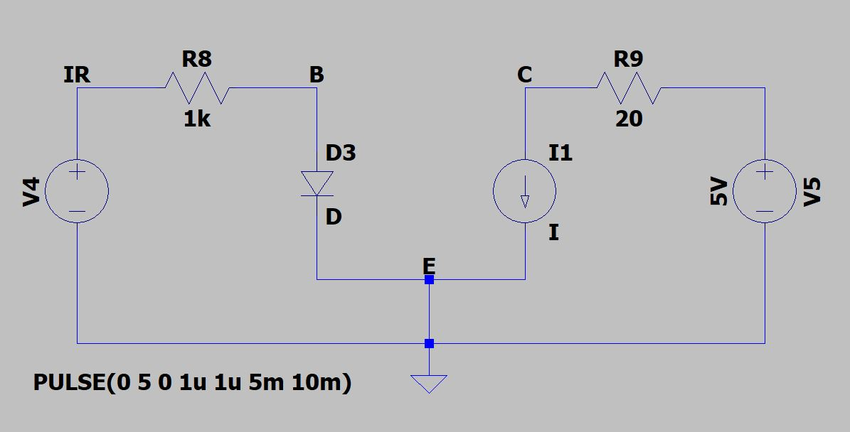

Figure 6: NPN Transistor Circuit for Analysis

The NPN transistor circuit in Figure 5 is equivalent to the circuit in Figure 6 which we can use for analysis. Using circuit analysis we can calculate the voltage at point C in the cases when the voltage source $V_{4}$ pulses between 5V and 0V representing the IR module that enters the base of the transistor. The voltage of point C enters the positive terminal of the switch in the schematic and drives the NE555 circuit output.

We can understand the function of the transistor when the IR module outputs 5V by comparing the values of the current at the base ($I_{B}$) and the current at the collector ($I_{1}$).

The loop on the right in Figure 6 can be analyzed using Ohms Law to calculate $I_{1}$. Since the current across a resistor is equal to the quotient of the voltage across it and the value of resistance, the current $I_{1}$ can be calculated using Ohms law across the resistor R9. This is calculated in Equation 1.

$I_{1}=\frac{V_{5}}{R9}=\frac{5V}{20Ω}=0.25A$

Equation 1: Calculation of $I_{1}$ in Figure 6

To get the value of $I_{B}$ we can utilize Kirchoff’s voltage laws to perform voltage analysis of the left side of the circuit in Figure 6.

Before motion is detected by the sensor the output of the module is 5V. Assuming the value across the diode, expressed as $V_{BE}$, is 0.7V we can use Kirchoff’s voltage laws to come up with the following equation.

$0V= -V_{IR}+V_{R8}+V_{BE}$

Equation 2: Kirchoff’s Voltage Law for Left Loop of Figure 6

The voltage across the resistor is equivalent to the product of the current source $I_{B}$ and the resistor value $R_{8}$. Replacing $V_{R8}$ with $( I_{B}⋅R_{8})$ and some simple algebraic manipulation leads us to the calculation in Equation 3.

$I_{B}=\frac{V_{IR}-V_{BE}}{R_{8}}=\frac{5V-0.7V}{1000Ω}=4.3mA$

Equation 3: Calculation for $I_{B}$

By comparing the current at the base given in Equation 3 with the current at the collector given in Equation 1 we see that the current at the collector is much greater than the current at the base and the transistor is in cut-off mode and acts like an open circuit.

$I_{c}=0.25A>I_{B}=4.3mA$

The voltage at point C can be calculated using voltage analysis of the right loop in Figure 6. The voltage at C will be 0V before motion is detected because the voltage from the voltage source $V_{5}$ drops across the resistor R9 and the voltage at C is equivalent to ground or 0V.

Since the voltage at the positive terminal of the switch is 0V the switch is open and we can begin to analyze the NE555 portion of the circuit.

Before motion is detected the supplied voltage of 9V is divided across the two 220kΩ resistors shown as R3 and R4 in Figure 4. These voltage division calculations are as follows:

$V_{CC}⋅\frac{220kΩ}{220kΩ+220kΩ}=V_{CC}⋅\frac{220kΩ}{440kΩ}= \frac{Vcc}{2}$

Equation 4: Voltage Division Calculation

Half of the supply voltage is 4.5V. The trigger value for pin 2 of the NE555 is one-third of the supply voltage which is 3V. Since 4.5V > 3V the output of pin 3 is “off” and the NE555 outputs approximately 0V. This level of voltage does not power the LED which reflects that there has not been motion detected.

After Motion is Detected

We can understand the function of the transistor when the IR module outputs 0V and motion is detected by once again comparing the values of the current at the base ($I_{B}$) and the current at the collector ($I_{1}$).

The calculation and explanation for Equation 1 is the same, so the value of $I_{1}$ is still 0.25A.

To get the new value for $I_{B}$ we can utilize Kirchoff’s voltage laws to perform voltage analysis of the left side of the circuit in Figure 6.

After motion is detected by the sensor the output of the module is 0V. Since the voltage of this loop is 0V we know that the current in the loop is 0A.

By comparing the current at the base with the current at the collector given in Equation 1 we see that the current at the collector is much greater than the current at the base and the transistor is in ...

$I_{c}=0.25A>I_{B}=0A$

Since the voltage at the positive terminal of the switch is 5V the switch is open and we can begin to analyze the NE555 portion of the circuit.

The closing of this circuit allows the capacitor labeled C1 in Figure 4 to draw current through it which decreases the voltage across R3 to below $\frac{1}{3}⋅Vcc$ which is the trigger value. This means the output of pin 3 of the IC will be “on” and 9V will travel out of pin 3 through the current limiting resistor to the LED. The LED will be lit up to represent that motion has been detected.

No Motion

At this point in time motion has just been detected and the NE555 is outputting “high” which fully charges the capacitor through the R1 resistor. The switch is once again open. When the switch opens back up the capacitor is drains through the resistor connected to the threshold input. The voltage discharge of the capacitor causes the value of the threshold (pin 6) to register a voltage above $\frac{2}{3}⋅Vcc$ which resets the internal flip-flop of the NE555 so that the output of pin 3 returns to 0 V and the LED is off.

Now the circuit has returned to its original set up and the motion-detecting process can begin once again.

ABET Outcomes and Motivation

The process of engineering a circuit that fulfills requirements and behaves appropriately requires deep analytical skills and proper experimental processes. We found that throughout the entirety of circuit development from focusing on the design of the circuit with theory, to then simulating the process using a software, and finally building a physical circuit that we had to have an ability to conduct appropriate experimentation, analyze and interpret data, and use engineering judgment to draw conclusions and troubleshoot areas of error. After identifying these errors we also had to formulate possible solutions to issues and to acquire and apply new knowledge as needed, using appropriate learning strategies to complete the project. As you review this document there will be monumental evidence of the ways we gained proficiency in testing, drawing conclusions, and engineering solutions for the construction of this circuit.

The circuit is designed to be constructed in 60 to 90 minutes and would be challenging yet interesting for a high school student or college freshman to build. The construction of the circuit would teach students the functionality of an op amp for voltage gain, and the benefit of using a transistor as a switch. They would additionally get to understand the NE555 quick timing operations and have a basic understanding of the control of signals using input and output devices like the IR module and LED output indication. This basic circuit can be useful in training for much larger projects. Control systems and automation are critical in today’s world and having an understanding of motion detector circuits serves one well in developing more detailed circuits for health and safety of operations.

### Simulation Model & Results

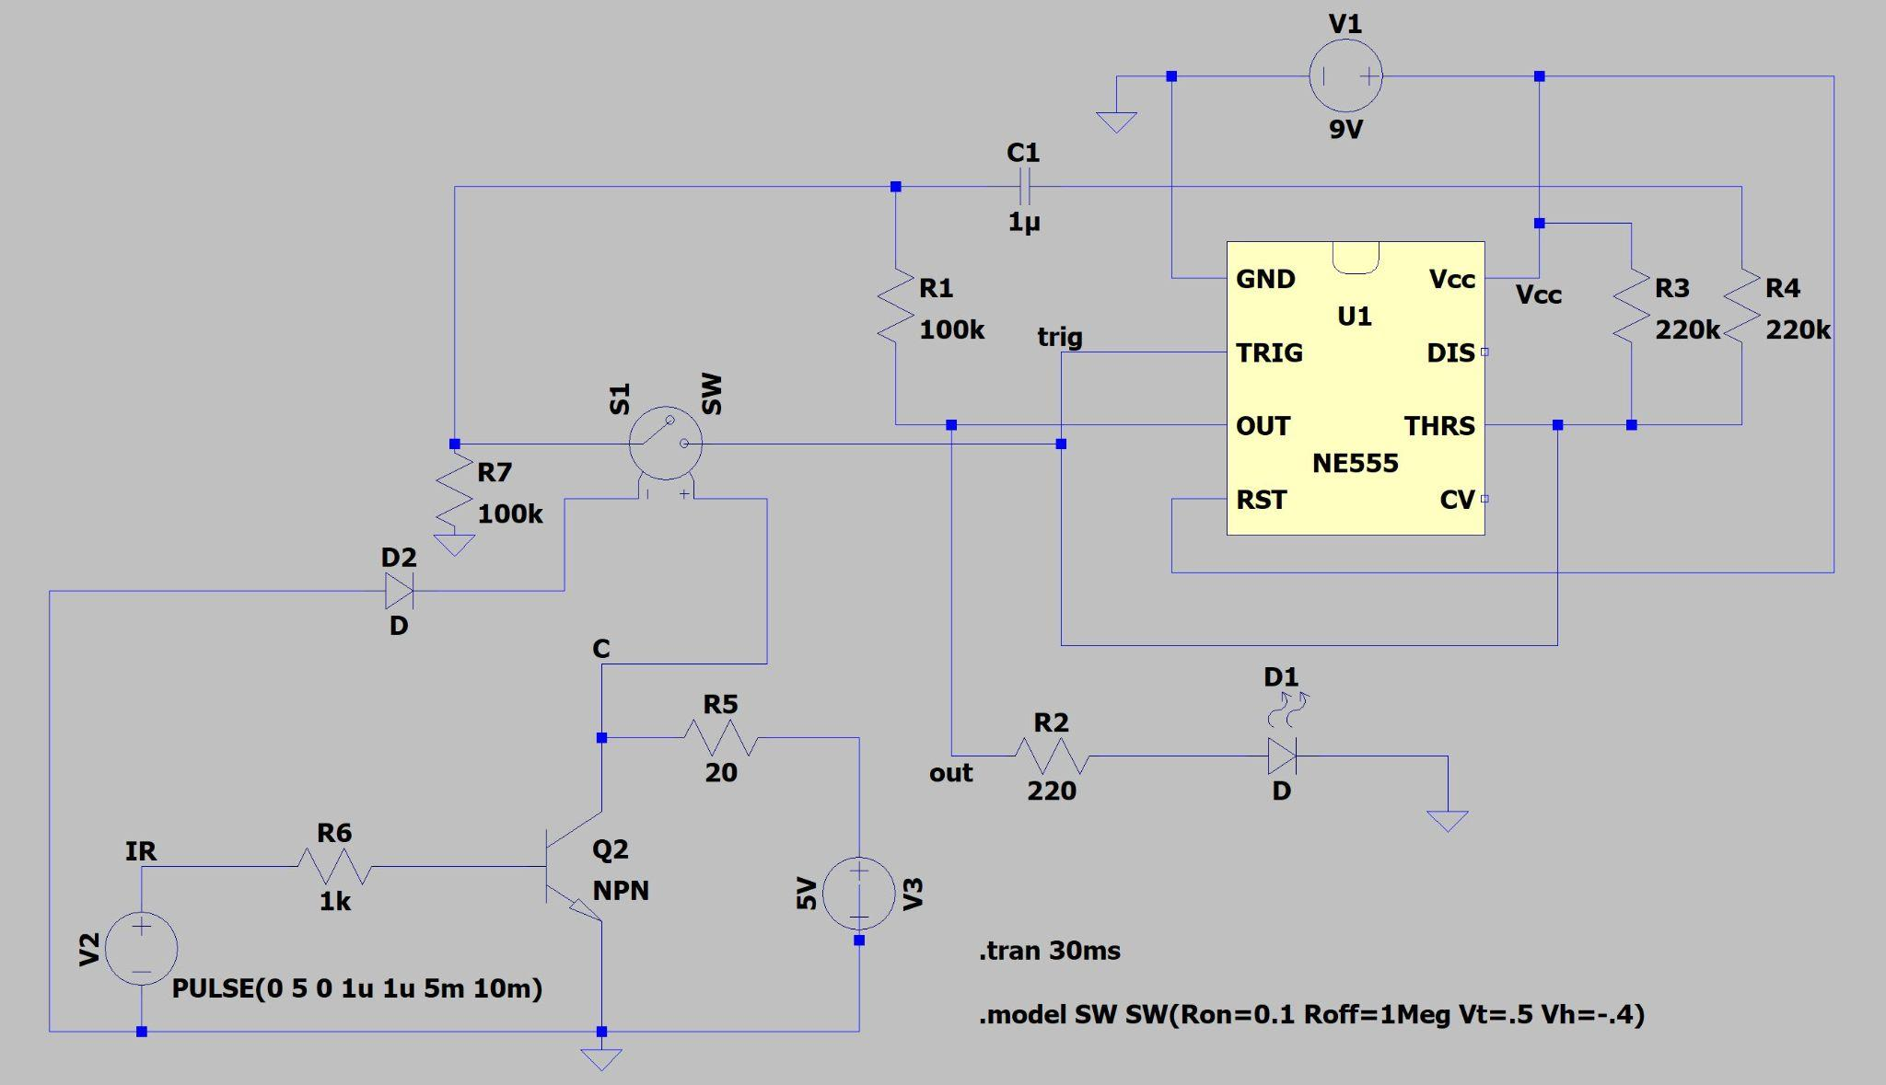

Figure 7: LTSpice Motion Detector Schematic

Figure 1 is an image of our IR motion detector circuit schematic modeled in LTSpice. The simulation collects data for 30 ms of data and displays 3 periods of data.

The pulse voltage source V2 represents the output of the IR sensor module which drives the circuit. The module outputs a voltage of 5V when no motion is detected and a voltage of 0V when motion is detected which is why a pulse voltage source was utilized to represent the module. The voltage output of the IR module can be measured at point IR on the model which travels through the resistor R6 into the base of the NPN transistor. The voltage at point C represents the voltage of the collector pin of the NPN transistor. The graphs in Figure 8 depict the relationship between the signal voltages at these two points over time. The collector voltage of the transistor is the flipped value of that of the IR Module which aligns with the behavior of an NPN transistor set up as seen in Figure 7. This behavior is explained further in our circuit theory.

Figure 8: Voltage at Points IR and C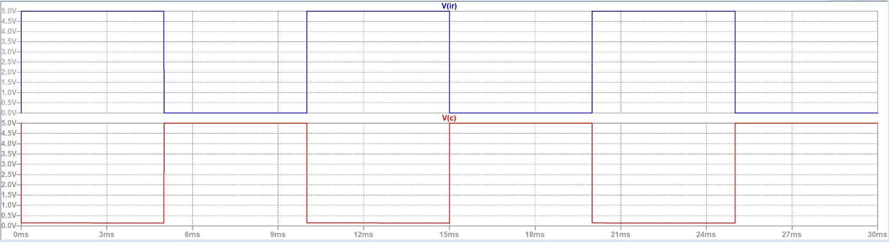

We can apply these results to understand that the switch S1 will be open when the voltage at point C is zero (when the IR sensor detects no motion and outputs 5V) and the switch will close when the voltage at point C is 5V (when the IR sensor detects motion and outputs 0V).

The operations of the NE555 over time can be understood by examining the input voltages of pins 2 and 6 as well as the output voltage of pin 3 over time. The point trig was placed in the simulation to see the input voltages of pins 2 and 6 and the point out was placed in the simulation to see the results of the output voltage over time.

Figure 9: Voltage at Points C, trig, and out in Figure 7 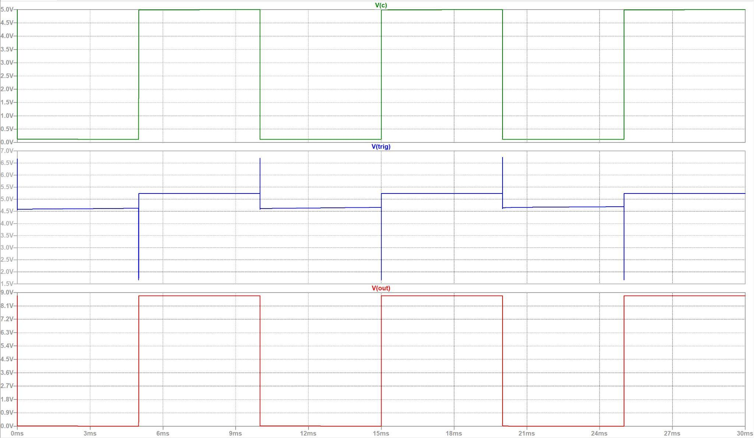

We can see from Figure 9 that at the beginning of the simulation when no motion is detected the voltage at pins 2 and 6 is approximately 4.5 V which is half the supply voltage of 9V. As explained in the circuit theory section, this is due to the voltage division of the supply voltage across two equivalent resistors as calculated in Equation 4. The voltage stays at approximately 4.5 V until 5ms when the voltage drops down to almost 1.5V. This happens when the IR module detects motion and the voltage at point C is 5V. As explained previously in the circuit theory the reason for this drop in voltage is due to the flow of current through the capacitor, since the switch is now closed and the circuit is completed. Since the drop in voltage is below the trigger value of 3V the output of pin 3 becomes almost that of the value of Vcc which drives the LED to light indicating motion has been detected.

From 5ms to 10ms during which the motion has been detected we see that the trigger voltage is at approximately 5.2V as the circuit is closed and the capacitor is fully charged. This value is kept constant until 10ms when the voltage of the collector returns to 0V. This means that motion is no longer detected and the switch is once again opened. The capacitor is fully charged and the opening of the circuit means that the capacitor can discharge. This causes the spike in the trigger voltage at 10ms which rises above 6.5V. 6.5V is greater than the threshold value of 6V which resets the NE555 output to zero which is seen from 10ms to 15ms on the V(out) graph of Figure 9.

Since the NE555 is reset the entire process can happen again once motion is detected as seen in the periodic nature of the graphs over time.

During the simulation process, there were challenges with grounding the circuit properly and with having the proper input to switch S1. A useful way to troubleshoot during the simulation process is to break the many parts of the circuit down into smaller parts to ensure that each piece is working properly. This can help ascertain the part that is truly in need of troubleshooting.

Utilizing this troubleshooting method, the circuit was broken down into the NE555 timer circuit shown in figure 10, and the NPN transistor circuit shown in figure 11. This was extremely helpful to identify issues in each part of the circuit and to resolve them in a timely manner.

Figure 10: NE555 Timer circuit Figure 11: NPN Transistor Circuit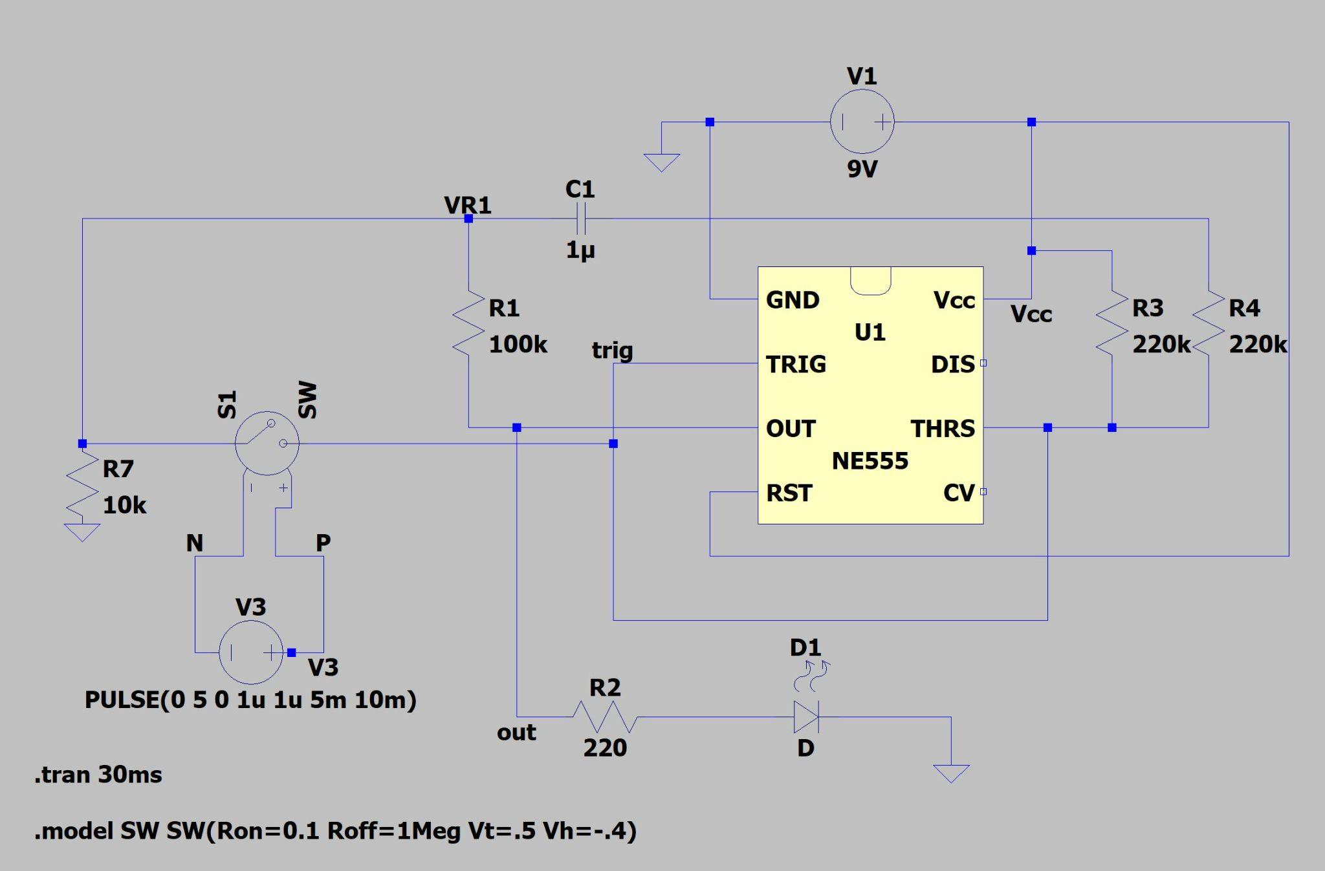

### Experimental Results

Figure 12: Experimental Setup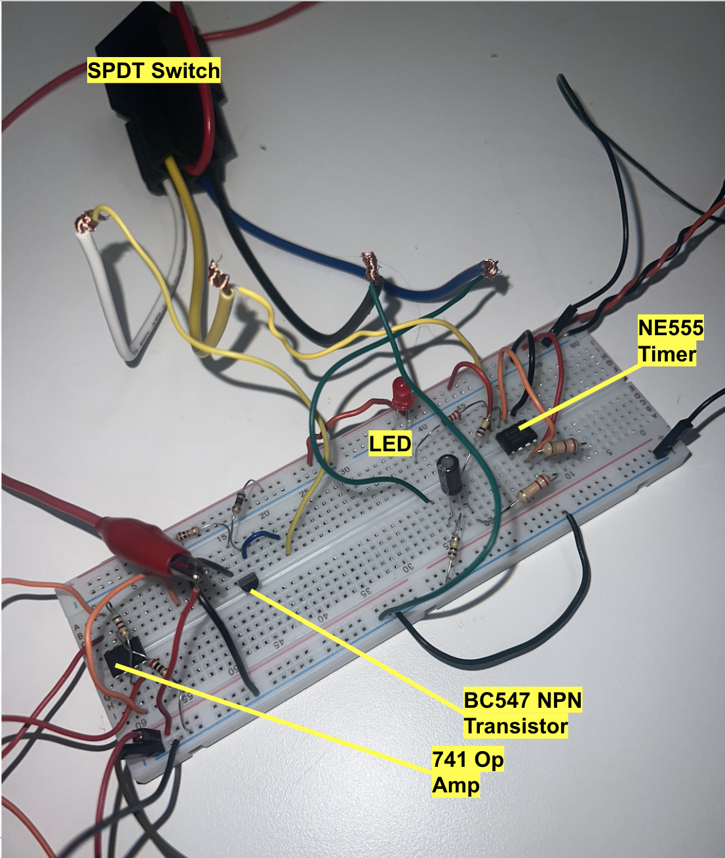

EPauto SPDT Relay

Figure 13: SPDT Switch (BOM Item #13)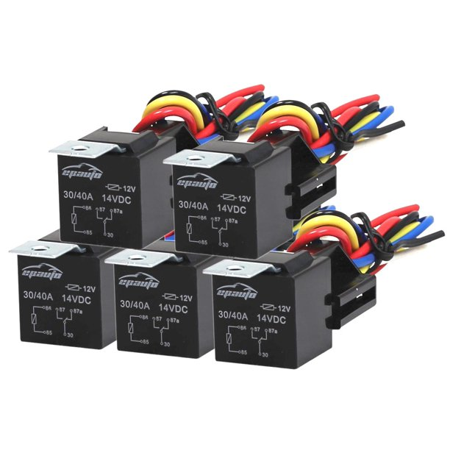

Though typically used for automotive applications, a 12V Relay Harness SPDT Switch was used in this circuit. The switch has 5 pins, each with a different colored wire to denote its purpose. The white wire is the positive side which is connected to the collector output of the transistor, while the black wire is connected to ground. The blue wire is the input side of the switch and the yellow wire is the output side of the switch when it is closed. This means that the blue wire is connected to the output of the electrolytic capacitor and the yellow wire is connected to pins 2 and 6 (the trigger and threshold inputs of the NE555). Since we needed the relay to function as a single pole single throw switch the yellow wire, or the normally open pole was used instead of the red wire which is the normally closed pole. The red wire was not used at all in this application and could be set aside.

In partnership with an IC-741 Op Amp, and NE555 timer, a BC547 NPN Transistor, and an IR Sensor Module, the SPDT Switch makes an audible click when the motion detector senses motion to turn the LED on or off. During experimentation, it was found that to operate the switch and show detected motion the voltage through the switch had to exceed 8.71V to indicate that motion was detected and light the LED (BOM Item #3) or stay below 4.33V to turn the LED off.

NE555 Timer

The output of pin 3 was approximately 0V until the input to pin 2, the trigger, fell below ⅓ the value of Vcc (which was 13V) and the internal flip flop of the IC was set. This threshold value of ⅓ the Vcc is about 4.33V. After this, the value of pin 3 was “high” or approximately 13V until the flip-flop was reset. Pin 4, the reset pin, is an input that can be triggered for a “low” signal. Pin 4 is connected to Vcc in this circuit so that the flip flop is only reset due to the input of the IR module. The only way that the output of pin 3 can be reset is when the trigger (pin 2) is above 4.33V and the threshold value (pin 6) is above $.67⋅Vcc$ which is 8.71V. This causes the flip flop to reset and the output value of pin 3 to be “low”.

IC-741 Op Amp

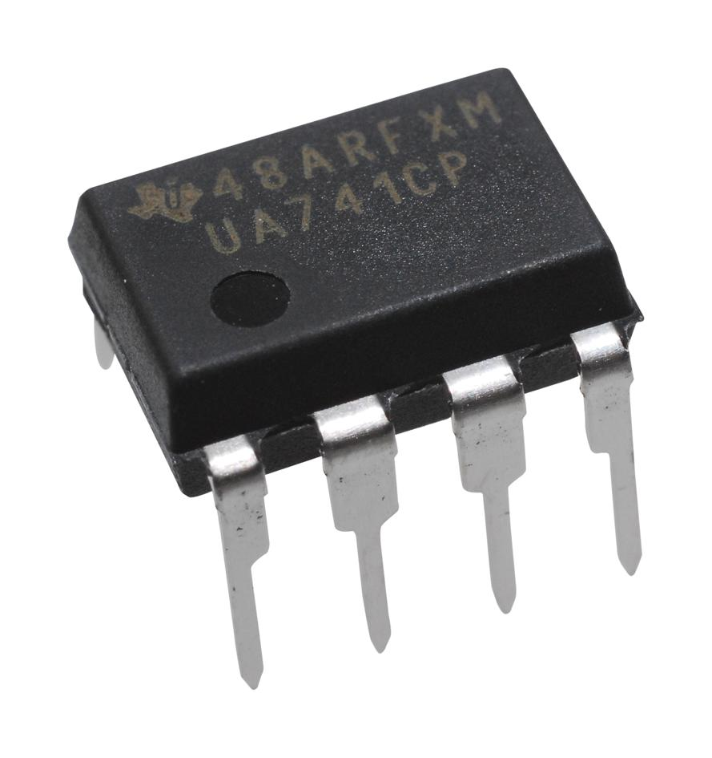

Figure 14: IC 741 Op Amp (BOM Item #14)

Initial tests without the 741 Op Amp (BOM Item #14) were unsuccessful due to the range of voltage being too small and not exceeding both limitations of the switch. The addition of the op amp allowed for amplification of the current, widening the range past the necessary thresholds so that motion detected operates the switch and LED correctly.

We set up the Op amp to be a non-inverting op-amp with two resistors valued at 510 Ohms and 200 Ohms. The equation for the gain of the non-inverting op-amp is written below:

$Gain = 1+\frac{R_{F}}{R_{In}}=1+\frac{510 Ω}{200 Ω}=3.55$

Equation 5: Gain of a Non-Inverting Op-Amp

As seen in Equation 5, the op-amp was set up so that the 510 Ohm resistor was used for RF and the 200 Ohm resistor was used for Rin. This gain was sufficient to increase the voltage of the output of the IR sensor module and create a large enough range for the relay to function correctly.

The output of the op-amp was supplied as the input to the base of the NPN transistor after running through a 10k $Ω$ resistor.

BC547 NPN Transistor

The main function of this transistor was to operate as a switch. The transistor is in cut-off mode when the voltage across the base and emitter is less than 0.7V. In this mode, the transistor acts as an open circuit and no current is flowing. The transistor is in saturation mode when the voltage across the base and emitter is greater than or equal to 0.7V and the voltage across the collector and emitter is equal to 0.2V. In this mode, the transistor acts as a closed circuit and current flows through the transistor. The transistor is in saturation mode when the voltage across the base and emitter is greater than or equal to 0.7V and the voltage across the collector and emitter is greater than 0.2V. In this mode, the transistor acts as a current amplifier. The voltage of the circuit fluctuates between the ranges of .7V and .2V which allows the transistor to operate as a switch.

**Brief Demonstration Video Link:** <https://youtube.com/shorts/_g3-X4tCO18>

### Analysis of Results

Section Differences

The main difference between our circuit theory and simulation compared to our experimental results is the presence of the IC-741 Op Amp in the circuit. Current amplification past the scope of the NPN transistor was necessary to power the relay properly, which is why the solution was to add the IC-741 Op Amp. In doing this, the range of voltage became wide enough to accommodate the SPDT Switch and allow it to work as needed. The voltage value needed to exceed 8.71V, or ⅔ of the Vcc (13V) when the IR sensor module sensed motion and switched to ground and the LED turned on. When the IR sensor module did not sense motion and stayed at a constant 5V, the voltage value needed to drop below 4.33V, which is ⅔ of the Vcc so that the LED would turn off.

Additionally, our simulation as seen in Figure 7 displays the voltage of V3 to be a 5V source which influences the collector voltage that drives the switch. This had to be increased to approximately 13 V in our experimental design so that the switch was powered properly.

The specific switch that was chosen created this challenge. The SPDT Switch was consuming more power than anticipated which was initially causing the range of voltage values to be too small and not exceed the thresholds of the switch. By using the IC-741 Op Amp to create a gain, the current was amplified and the range of voltage values was increased. While the circuit can work correctly with this switch in the future, a switch that is powered by a much lower voltage would be more ideal than the 12V switch that we used. A SPST Switch would also be more appropriate than the SPDT Switch that was used.

Section Similarities

The NE555 timer portion of the circuit worked well consistently throughout the project from circuit theory, to simulation, to experimentation. We had no trouble with building the circuit for it properly based on the simulation results and we also found that this circuit continually worked when we increased the supply voltage from 9V in the simulation to 13 V in the experimentation phase.

Most other aspects of the project were also consistent from simulation, to theory, and finally to experimentation. The transistor operated as it was supposed to and reversed the signal as intended. The IR Sensor Module was successful in sensing motion and releasing the corresponding 0V for motion detected or constant 5V for no motion detected, and while the SPDT switch was a challenge to learn and implement, it accomplished its purpose as a proper switch for the motion detector.

### Conclusion

In conclusion, our report dissects the circuit building process for an infrared motion detector circuit. It highlighted major issues we encountered, our solutions for said issues, and emphasized why this project is one that is incredibly useful for gaining experience for real-world applications. Our step-by-step walkthrough of the theory behind the circuit and its functionality provides deep analytical insight into our circuit and provides an opportunity to understand real world applications for transistors and op-amps.

We designed this circuit to foster interest in understanding the control of input and output signals from a commonly used input such as the infrared sensor module for high school and college students. In addition to reaching this goal and building a fully functioning circuit, we found ourselves gaining a deeper understanding of electrical components and learning new troubleshooting techniques that will serve us well in our future careers as engineers.

### Appendix

Simulation Models

Link to LTSpice Schematic: [Circuit_Simulation.asc](https://drive.google.com/open?id=1DOD1BBO-hXrpGzE2CWks4SUNv8rmCXM3&usp=drive_copy)

Bill of Materials

| Item # | Part Name | Part Number | Description | Quantity |
| --- | --- | --- | --- | --- |
| 1 | NE555 Timer | ASIN: B07WR9B4JT | BOJACK NE555 Timer IC | 1 |
| 2 | IR Sensor Module | ASIN: B07FJLMLVZ | Gikfun Obstacle avoidance IR Infared Sensor Module | 1 |
| 3 | LED | L57IID12V | Red LED (Used for indicating motion) | 1 |
| 4 | 51 Ohm Resistor | 2019-CF1/4CT52R510JCT-ND | 51 Ohm Resistor (Used for NPN Transistor) | 1 |
| 5 | 200 Ohm | S200QCT-ND | 200 Ohm (Used in Op Amp gain) | 1 |
| 6 | 220 Ohm Resistor | S220QCT-ND | 220 Ohm Resistor | 1 |
| 7 | 510 Ohm Resistor | 2019-CF1/4CT52R511JCT-ND | 510 Ohm Resistor (Used in Op Amp gain) | 1 |
| 8 | 1k Ohm Resistor | 2019-CF1/4CT52R102JCT-ND | 1k Ohm Resistor (Used for NPN Transistor) | 1 |
| 9 | 100k Ohm Resistor | 2019-CF1/4CT52R104JCT-ND | 100k Ohm Resistor (Used for NE555) | 2 |
| 10 | 220k Ohm Resistor | CF14JT220KCT-ND | 220k Ohm Resistor (Used for NE555) | 2 |
| 11 | 1µF Capacitor | EK1H010MP20511EU | 1µF 50 V Aluminum Electrolytic Capacitor | 1 |
| 12 | NPN Transistor | BC547 B331 | BC547 NPN Transistor used as switch | 1 |
| 13 | SPDT Switch | ‎AE-001-2 | EPAuto 30/40 Amp 12 VDC Bosch Style 5-pin SPDT Relay | 1 |
| 14 | IC 741 Op-Amp | UA741 | Texas Instrument UA741CP Op-Amp (Used for Voltage gain) | 1 |
| 15 | Wires | N/A | N/A | As Needed |
| 16 | Power Supply | N/A | One power supply utilized for 5V and 13V and another to have +/- 12 V for an op amp | 2 |

Citing Images

Figure 1: <https://www.google.com/url?sa=i&url=https%3A%2F%2Fusa.banggood.com%2F5Pcs-Geekcreit-IR-Infrared-Obstacle-Avoidance-Sensor-Module-For-Smart-Car-Robot-3-wire-Reflective-Photoelectric-p-1614234.html&psig=AOvVaw2SC42XnwVZhwzqtIADJ1tJ&ust=1669925468897000&source=images&cd=vfe&ved=0CA8QjRxqFwoTCJDShqXb1vsCFQAAAAAdAAAAABAF>

Figure 2: <https://www.elprocus.com/wp-content/uploads/2013/10/555-Timer.png>

Figure 3: <https://m.media-amazon.com/images/I/51gbMUYtz4L.jpg>

Figure 13: <https://i5.walmartimages.com/asr/cc1e8fef-8ad4-48ce-832b-ac254a7eb9a9.b534f7104f5aa34ef3ee913574c059aa.jpeg?odnHeight=612&odnWidth=612&odnBg=FFFFFF>

Figure 14: <https://www.newark.com/productimages/large/en_US/60K7043-40.jpg>